**ENSE 374 Clean Code Review – Milestone #3**

Space Minds

Anupras Burokas, Ahras Ali, Jack Zhao

November 13, 2019

Here are a couple snippets of code (lower right written in C++, the rest are in Python):

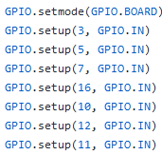

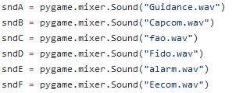

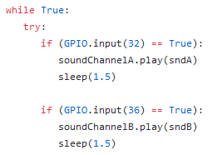

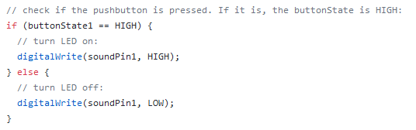

Why our code is clean?

* Good comments – one not familiar with this code should be able to easily figure out its purpose
* Variables have small scope – variables are not reused within different functions and loops
* Each variable has exactly one purpose – check the top left image, you can see that each variable corresponds to only one sound (its purpose); check the lower left image, here each variable is a channel for only one sound (instead of multiple sounds sharing the same channel, which would be bad practice)
* Good variable names – variable names that are not too short or too long, and which correspond to their purpose (sndA is a variable which holds a specific sound; soundChannelA is the channel in which sndA has to play through; soundPin1 is the first sound pin in the Raspberry PI, etc.)
* Our variables have optimum variable length name (anywhere from 8-20 characters). If a variable is reused a lot, and it’s purpose is self-explanatory, we shortened it even more (for example, sndA - sndF, are 4 characters long)